MLOps – Assignment Report
Heart Disease Prediction API

Name: Bhooshaan A

ID: 2025cs05032

Demo Recording Link:

https://drive.google.com/file/d/1waLydlMx2iI6unlLuzCD0gHqu7y6XuNH/view?usp=sharing

GitHub Repo Link:

https://github.com/Bhooshaan-2025cs05032/MLOps-Assignment

1. Project Overview
This project demonstrates a complete End-to-End MLOps workflow for a Heart Disease Prediction system. The project includes:
- FastAPI-based ML inference API
- CI/CD using GitHub Actions
- Docker containerization
- Kubernetes deployment using K3s
- Monitoring using Prometheus and Grafana
- ML experiment tracking using MLflow + DagsHub
- Image Store with GitHub Container Registry (GHCR)
- Ingress-based application exposure

2. Tech Stack
Category | Technology
Programming Language | Python
API Framework | FastAPI
ML Library | Scikit-learn
Experiment Tracking | MLflow
Remote Tracking | DagsHub
Containerization | Docker
CI/CD | GitHub Actions
Container Registry | GitHub Container Registry (GHCR)
Orchestration | Kubernetes (K3s)
Monitoring | Prometheus
Visualization | Grafana
Cloud | AWS EC2
Ingress | Traefik

3. Architecture Diagram of the E2E MLOps Pipeline
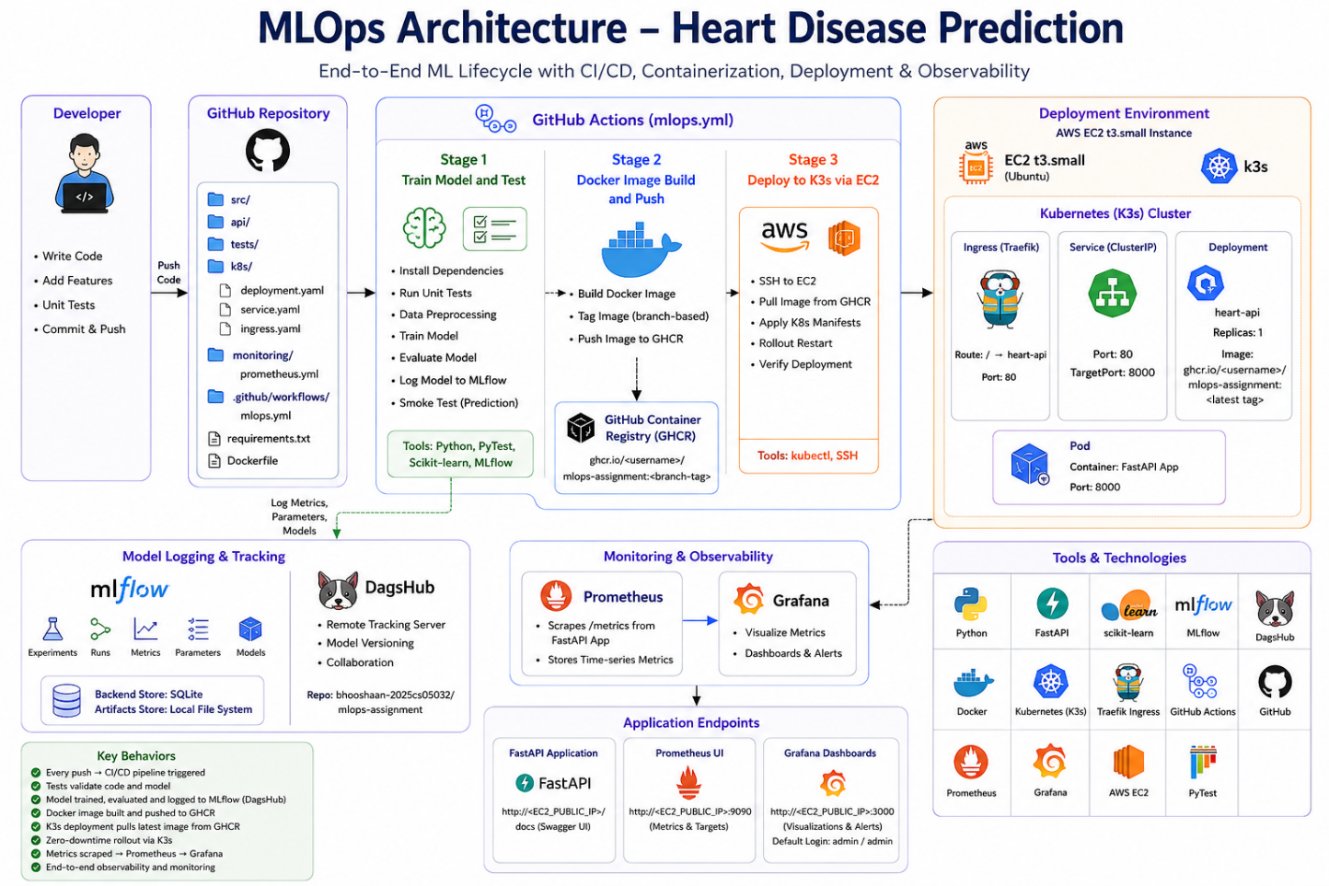

4. Setup/Install Instructions Guide

4.1. Local Project Setup

Clone Repository
git clone <YOUR_REPOSITORY_URL>
cd <REPOSITORY_NAME>
REPOSITORY_URL: https://github.com/Bhooshaan-2025cs05032/MLOps-Assignment.git

Create Virtual Environment
python3 -m venv mlopsenv

Activate Virtual Environment

Linux / Mac
source mlopsenv/bin/activate

Windows
mlopsenv\Scripts\activate

Install Dependencies
pip install -r requirements.txt

4.2. Run Training Pipeline

Configure MLflow / DagsHub Environment Variables
export MLFLOW_TRACKING_URI=<YOUR_MLFLOW_URI>
export MLFLOW_TRACKING_USERNAME=<YOUR_USERNAME>
export MLFLOW_TRACKING_PASSWORD=<YOUR_PASSWORD>

Run Data Processing
python src/data_processing.py

Train Model
python src/train_model_and_log.py

4.3. Run API Locally

Start FastAPI Application
uvicorn api.app:app --host 0.0.0.0 --port 8000

Access Swagger UI
http://localhost:8000/docs

4.4. Run Tests

Run Unit Tests
pytest tests/

Run Coverage
pytest tests/ \
--cov \
--cov-config=.coveragerc \
--cov-report=term-missing

4.5. Docker Setup

Build Docker Image
docker build -t heart-api .

Run Docker Container
docker run -p 8000:8000 \
-e MLFLOW_TRACKING_URI=<URI> \
-e MLFLOW_TRACKING_USERNAME=<USERNAME> \
-e MLFLOW_TRACKING_PASSWORD=<PASSWORD> \
heart-api

Verify API
http://localhost:8000/docs

4.6. AWS EC2 Setup

Create EC2 Instance
Recommended Configuration:
Property | Value
Instance Type | t3.small
OS | Ubuntu
Storage | 20 GB

Open Security Group Ports
Port | Purpose
22 | SSH
80 | Ingress / API
3000 | Grafana
9090 | Prometheus

4.7. Install Docker on EC2
curl -fsSL https://get.docker.com | sh

Add User to Docker Group
sudo usermod -aG docker ubuntu
newgrp docker

4.8. Install K3s Kubernetes
curl -sfL https://get.k3s.io | sh -

Configure kubectl Access
mkdir -p ~/.kube
sudo cp /etc/rancher/k3s/k3s.yaml ~/.kube/config
sudo chown ubuntu:ubuntu ~/.kube/config

Verify Kubernetes
kubectl get nodes

4.9. Kubernetes Deployment

Create Kubernetes Directory
mkdir ~/k8s

Kubernetes Manifests
Place the following files inside:
~/k8s/
├── deployment.yaml
├── service.yaml
└── ingress.yaml

Apply Manifests
kubectl apply -f ~/k8s/deployment.yaml
kubectl apply -f ~/k8s/service.yaml
kubectl apply -f ~/k8s/ingress.yaml

Verify Pods
kubectl get pods

Verify Ingress
kubectl get ingress

4.10. Prometheus Setup

Create Monitoring Directories
mkdir ~/monitoring
mkdir ~/prometheus_data

Create Prometheus Config
File:
~/monitoring/prometheus.yml
Content:
global:
scrape_interval: 30s
scrape_configs:
- job_name: "heart-api-k8s"
metrics_path: /metrics
static_configs:
- targets: ["localhost"]

Run Prometheus
docker run -d \
--name prometheus \
--restart always \
--network host \
-v /home/ubuntu/monitoring/prometheus.yml:/etc/prometheus/prometheus.yml \
-v /home/ubuntu/prometheus_data:/prometheus \
prom/prometheus

Access Prometheus
http://<EC2_PUBLIC_IP>:9090

4.11. Grafana Setup

Run Grafana
docker run -d \
--name grafana \
--restart always \
-p 3000:3000 \
grafana/grafana

Access Grafana
http://<EC2_PUBLIC_IP>:3000
Can create dashboards of your choice with queries for metrics

Default Credentials
Username: admin
Password: admin

Add Prometheus Data Source
http://<EC2_PUBLIC_IP>:9090

4.12. GitHub Secrets Setup
Configure the following GitHub Secrets:
Secret Name
EC2_HOST
EC2_SSH_KEY
MLFLOW_TRACKING_URI
MLFLOW_TRACKING_USERNAME
MLFLOW_TRACKING_PASSWORD

4.13. CI/CD Pipeline Overview
On code commit, the GitHub Actions workflow performs:
- Run unit tests
- Run preprocessing
- Train model
- Validate model artifact
- Build Docker image
- Push image to GHCR
- SSH into EC2
- Create/update Kubernetes secrets
- Apply Kubernetes manifests
- Perform rolling deployment

4.14. Deployment Verification

Verify Deployment
kubectl get deployments

Verify Pods
kubectl get pods

Verify Current Image
kubectl get deployment heart-api \
-o=jsonpath='{$.spec.template.spec.containers[0].image}'

Verify Rollout Status
kubectl rollout status deployment heart-api

4.15. Application Endpoints
Service | URL
FastAPI Swagger UI | http://<PUBLIC_IP or ELASTIC_IP>/docs
Prometheus | http:// :<PUBLIC_IP or ELASTIC_IP>/:9090
Grafana | http:// :<PUBLIC_IP or ELASTIC_IP>/:3000

5. Exploratory Data Analysis (EDA) and Modelling Choices

Dataset Understanding
The project uses a Heart Disease Prediction dataset containing clinical and medical attributes such as:
- Age
- Sex
- Chest Pain Type (cp)
- Resting Blood Pressure (trestbps)
- Cholesterol (chol)
- Fasting Blood Sugar (fbs)
- Resting ECG (restecg)
- Maximum Heart Rate (thalach)
- Exercise Induced Angina (exang)
- ST Depression (oldpeak)
- Slope
- Number of Major Vessels (ca)
- Thalassemia (thal)
The target variable represents the presence or absence of heart disease.

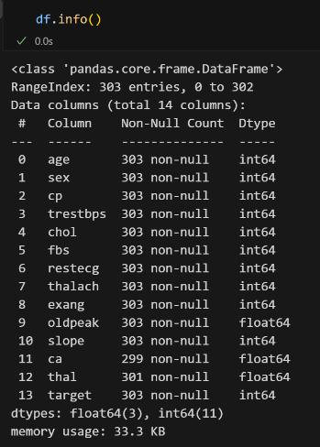
EDA Performed

1. Data Inspection
Initial analysis included:
- Checking dataset shape and schema
- Verifying missing values
- Inspecting feature distributions
- Identifying categorical and numerical columns

2. Statistical Analysis
Descriptive statistics were generated to understand:
- Mean
- Median
- Standard deviation
- Feature ranges
- Class balance
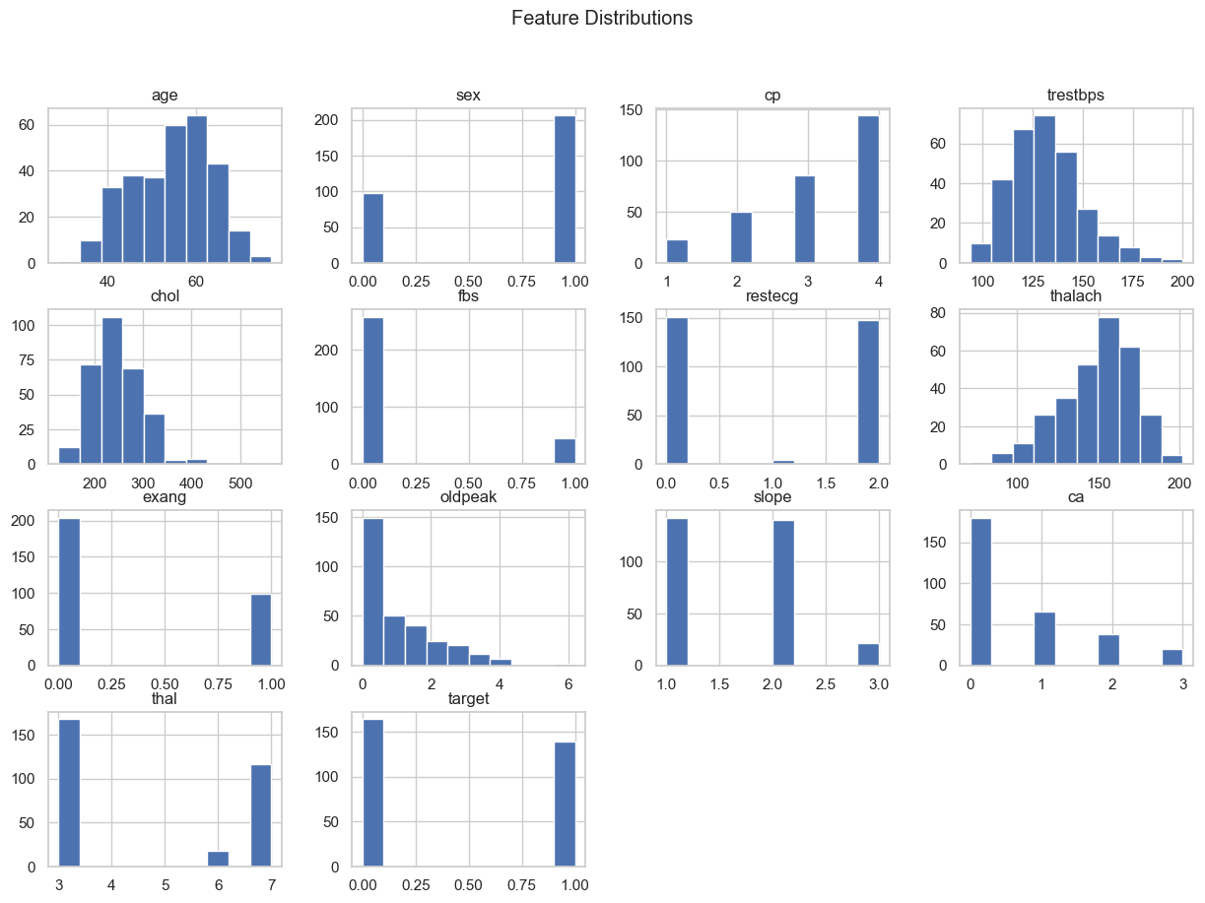
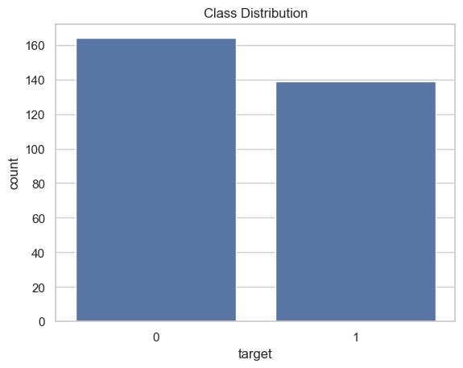
This helped identify potential outliers and understand feature spread.

3. Correlation Analysis
Correlation analysis was performed to:
- Understand relationships between features
- Identify highly influential variables
- Detect multicollinearity
Features such as chest pain type, maximum heart rate, exercise-induced angina, and ST depression showed meaningful correlation with the target.

4. Visualization
EDA visualizations included:
- Histograms
- Count plots
- Box plots
- Correlation heatmaps
These helped analyze:
- Feature distributions
- Outliers
- Target imbalance
- Feature importance trends
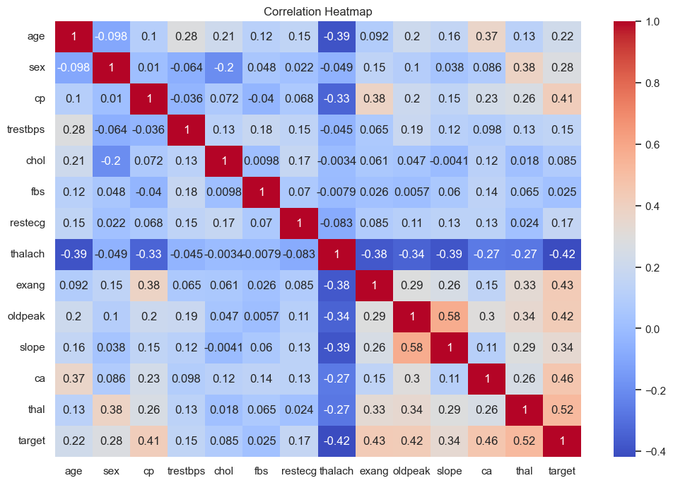

Data Preprocessing
The preprocessing pipeline included:
- Handling missing values (if any)
- Feature selection
- Data cleaning
- Train-test split
- Scaling / normalization where applicable
The preprocessing logic was modularized into a dedicated pipeline for reproducibility.

Modelling Choices

Selected Model
The project uses a supervised machine learning classification approach (Logistic Regression and Random Forest) for predicting heart disease.
Multiple classical ML algorithms were evaluated, with emphasis on:
- Interpretability
- Simplicity
- Performance on tabular medical data
- Faster inference
- Lower infrastructure requirements

Why Classical ML Instead of Deep Learning?
Deep learning was intentionally avoided because:
- Dataset size is relatively small
- Tabular healthcare data often performs well with classical ML
- Simpler models are easier to interpret
- Lower computational overhead
- Faster training and inference
This aligns well with production-friendly MLOps deployment requirements.

Evaluation Metrics
The model evaluation considered metrics such as:
- Accuracy
- Precision
- Recall
- F1 Score
- Confusion Matrix
Special importance was given to recall and F1-score due to the healthcare nature of the problem.

6. Model Tracking with MLflow – Experiment Tracking Summary
MLflow was used to:
- Track experiments
- Log hyperparameters
- Log metrics
- Store trained models
- Maintain experiment reproducibility
DagsHub was integrated as the remote MLflow tracking backend.
- Cross validation runs for hyperparameter tuning was logged for each model
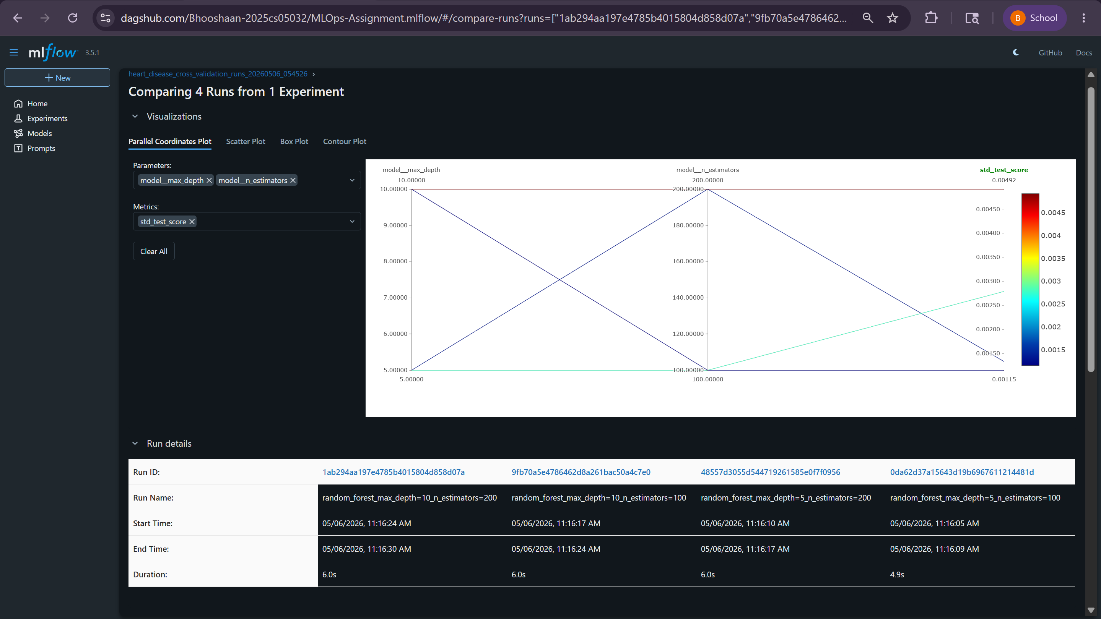
- For each model best hyperparameter version was logged for test metrics.
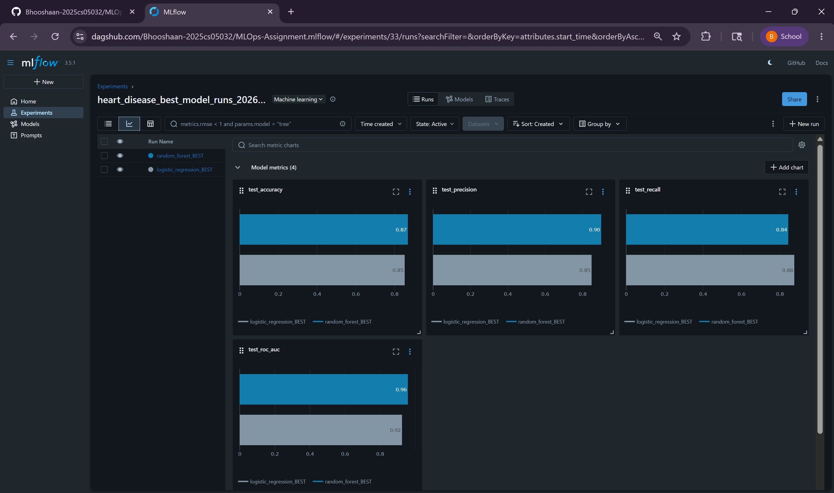
- Best model with high AUC-ROC was registered in the model registry (Every training registers the model with updated version) – Also Model Artifacts with env recreation files stored.
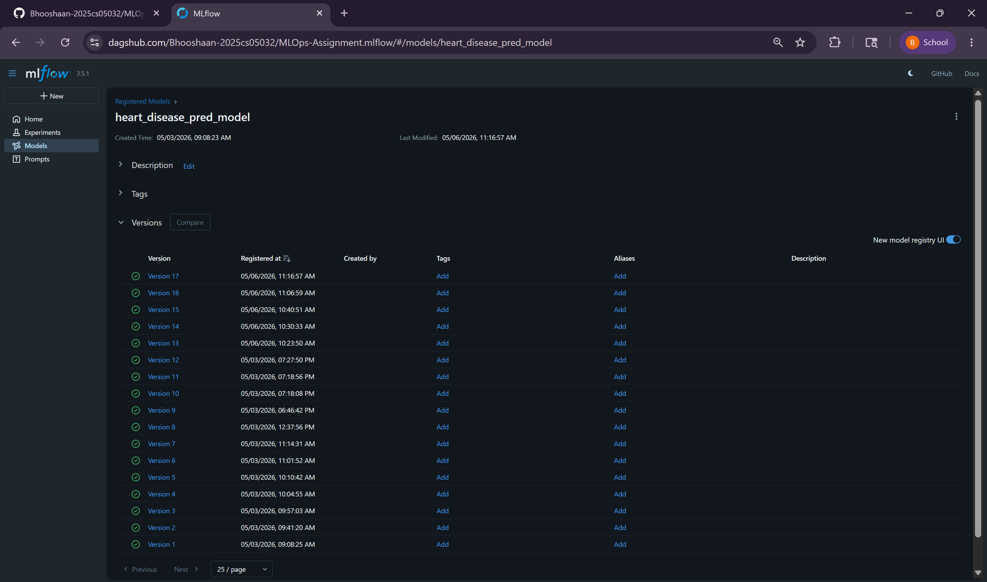
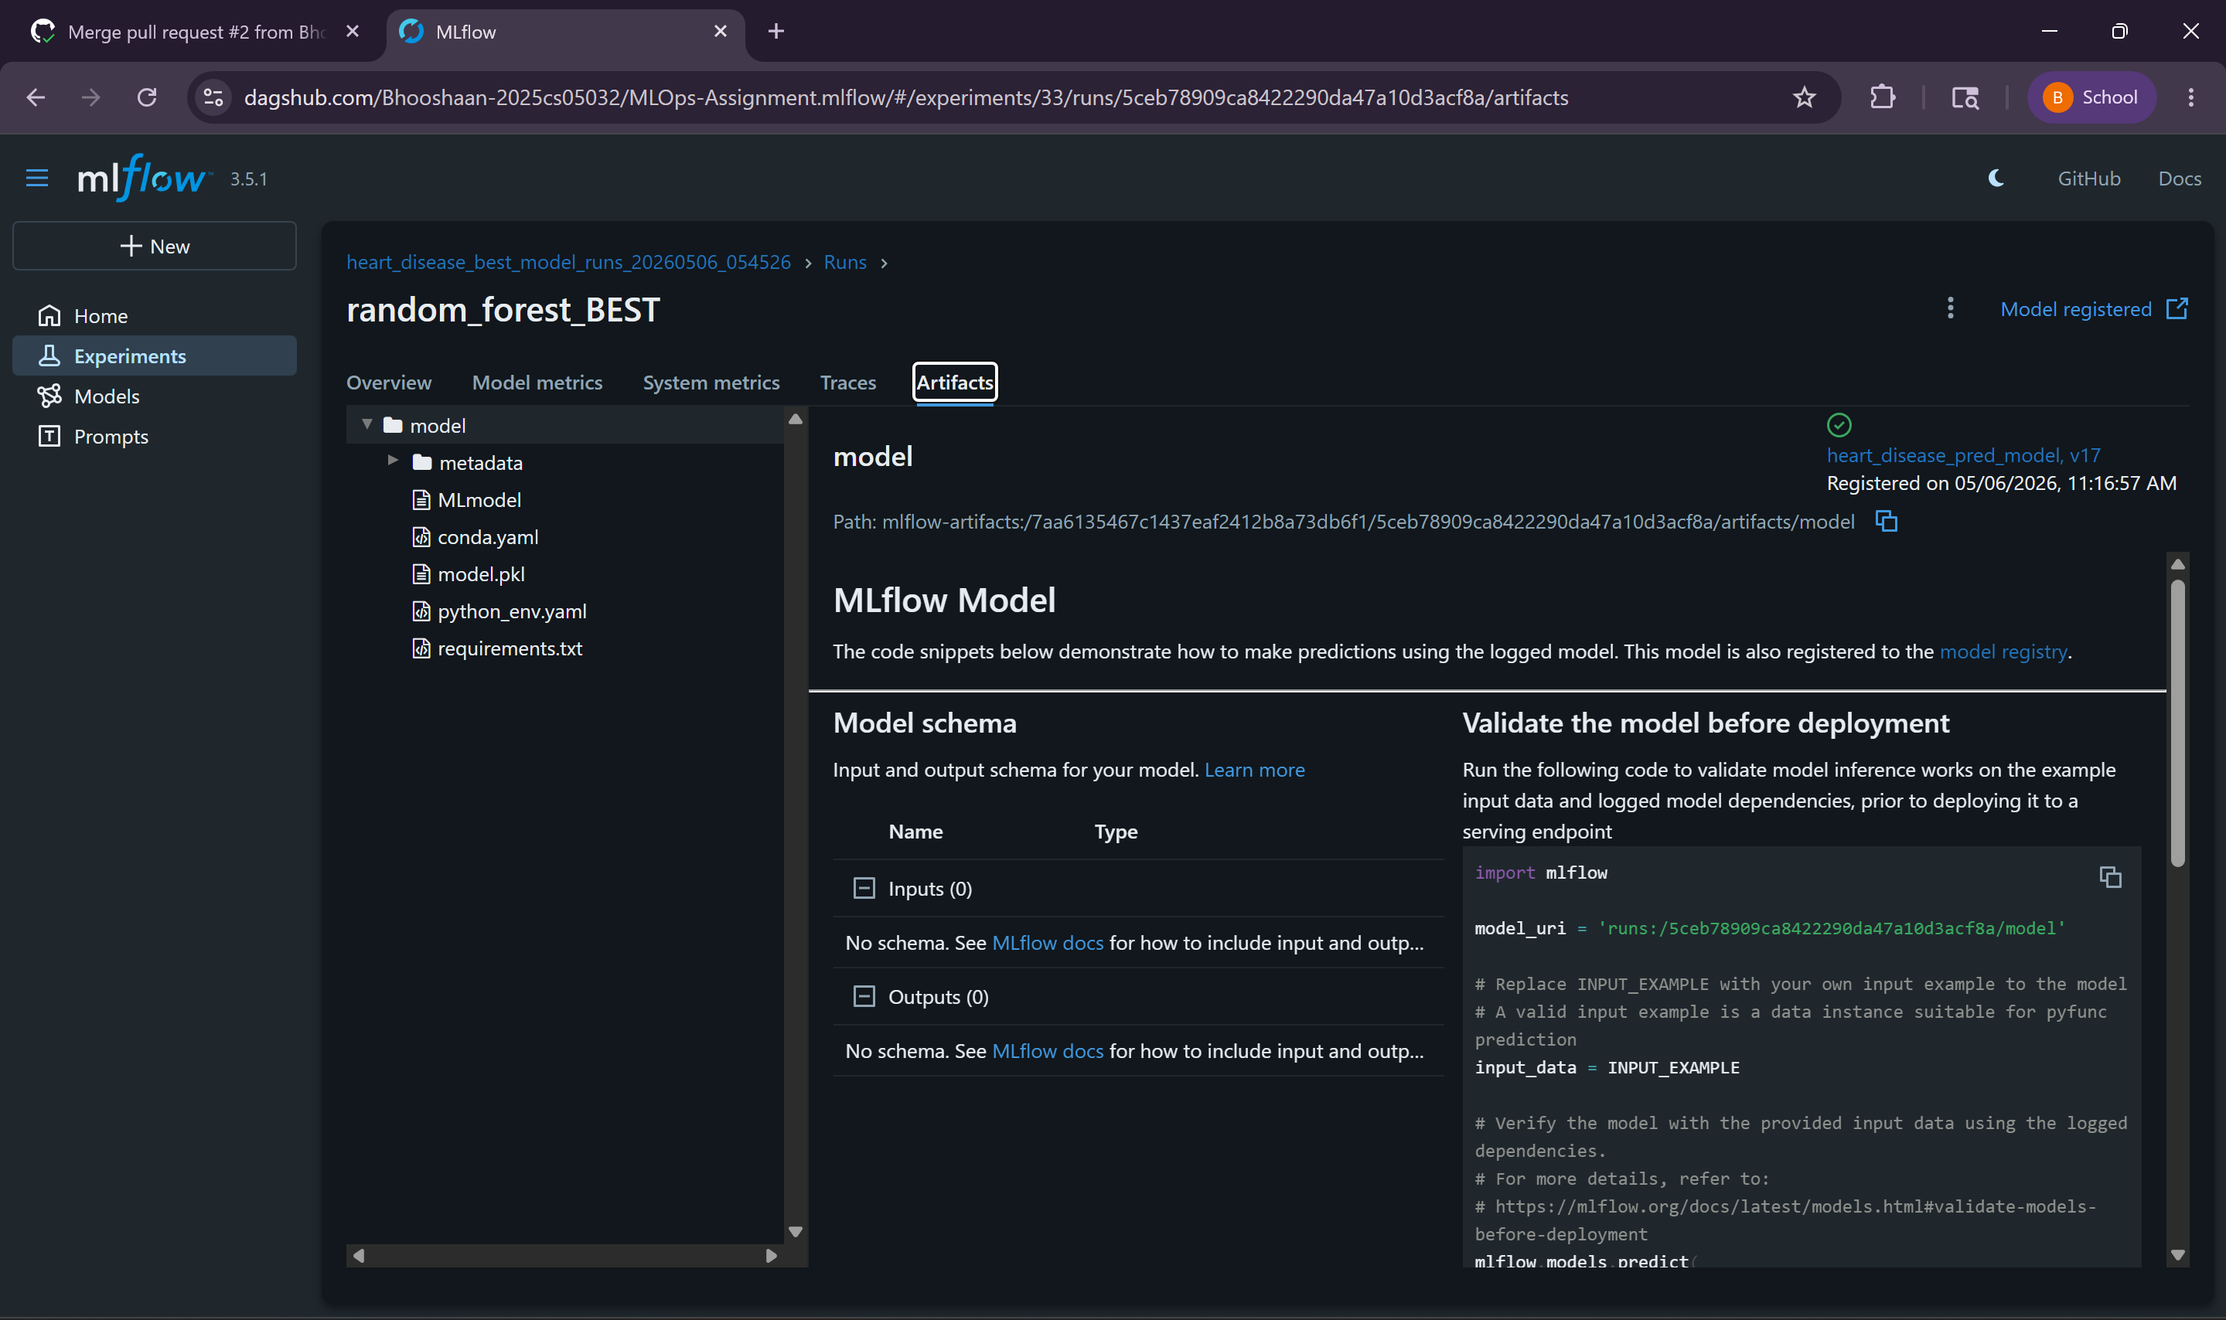

7. CI CD Deployment Workflow
- Github Actions was used for CI/CD Pipeline

- Phase 1: Build-Train-Test: Fetches data, installs requirements in a clean environment, runs unit tests and fails if coverage is less than 80%, pre-processes and cleans data, trains model and logs the artifacts to DagsHub-MLFlow and registers best model.
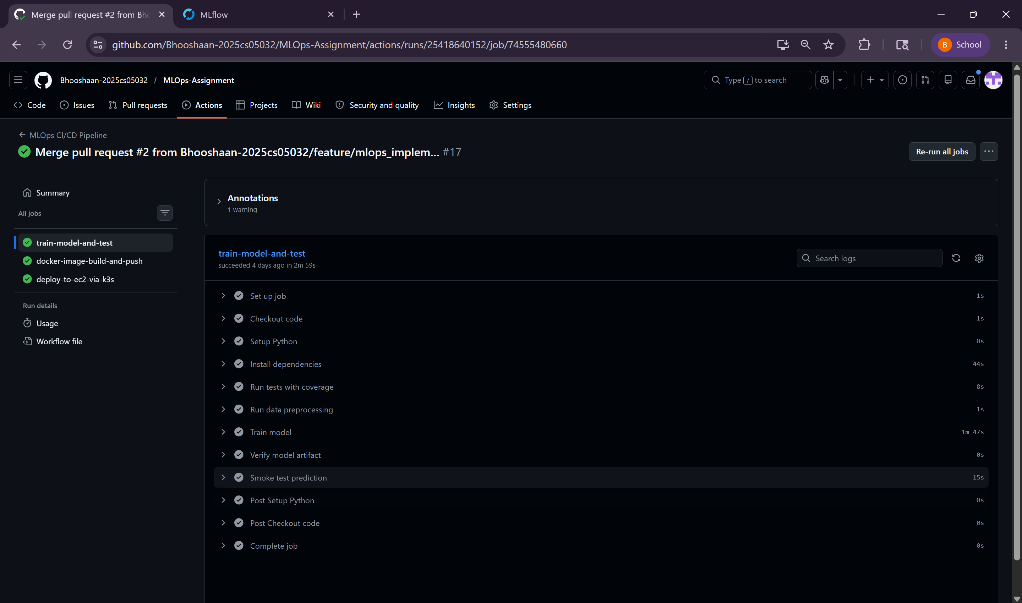
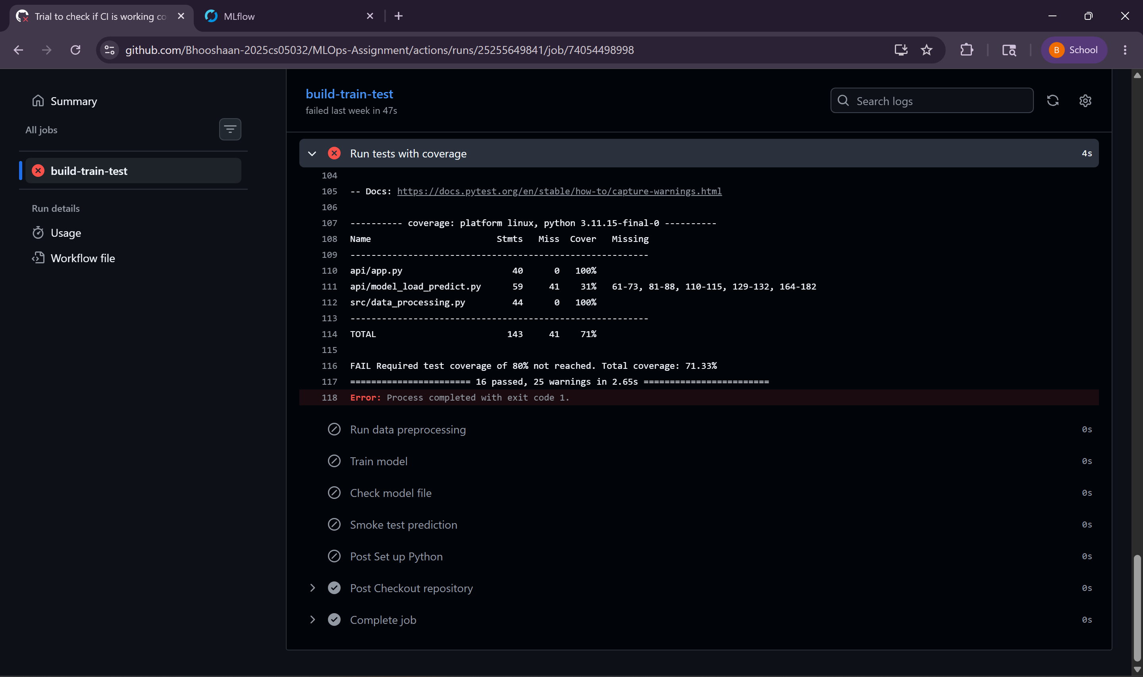
(Tests failed as coverage is just 71.33%)

- Phase 2: Docker Image Build and Push: Fetches pkl file file DagsHub – MLFlow Model registry, builds docker image and pushes it into Github Container Registry
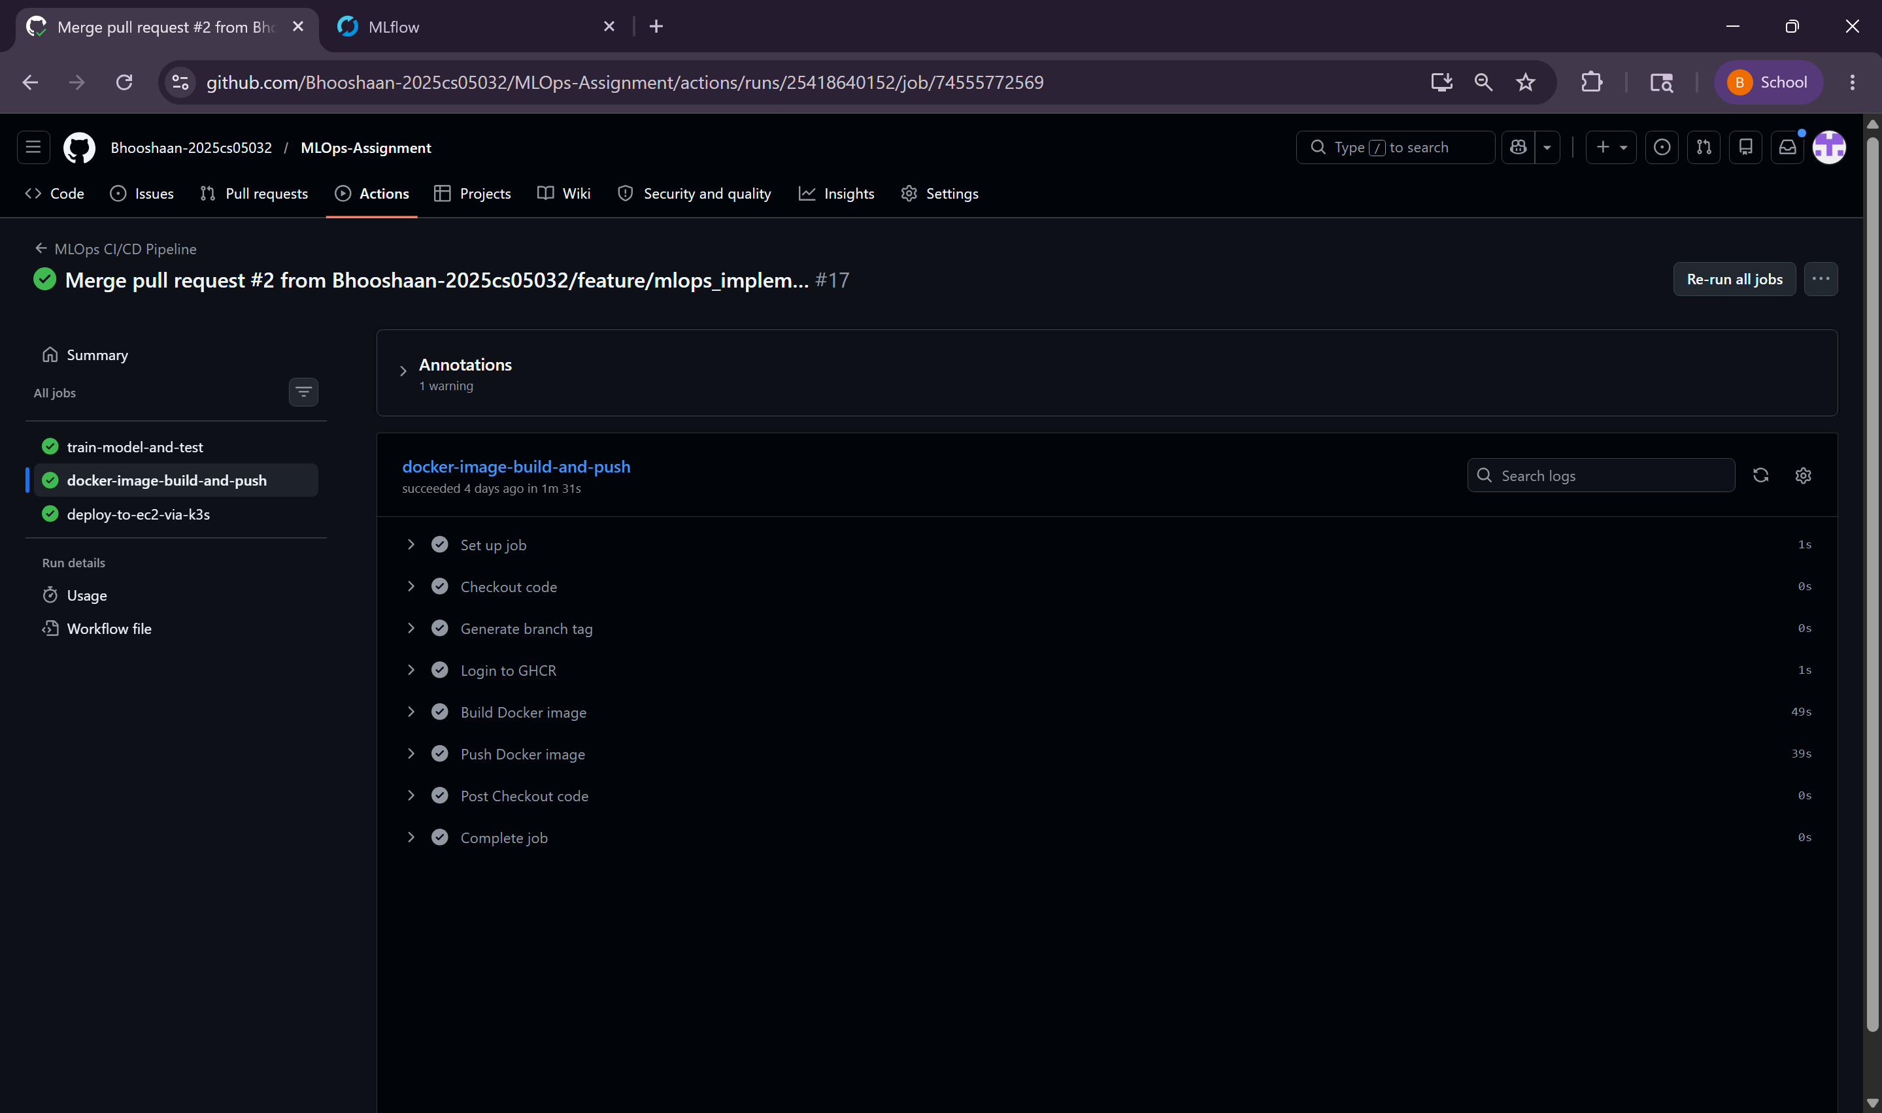

- Phase 3: Deploy to EC2 via K3S: Pulls the latest image from GHCR and deploys in on K3S Pods
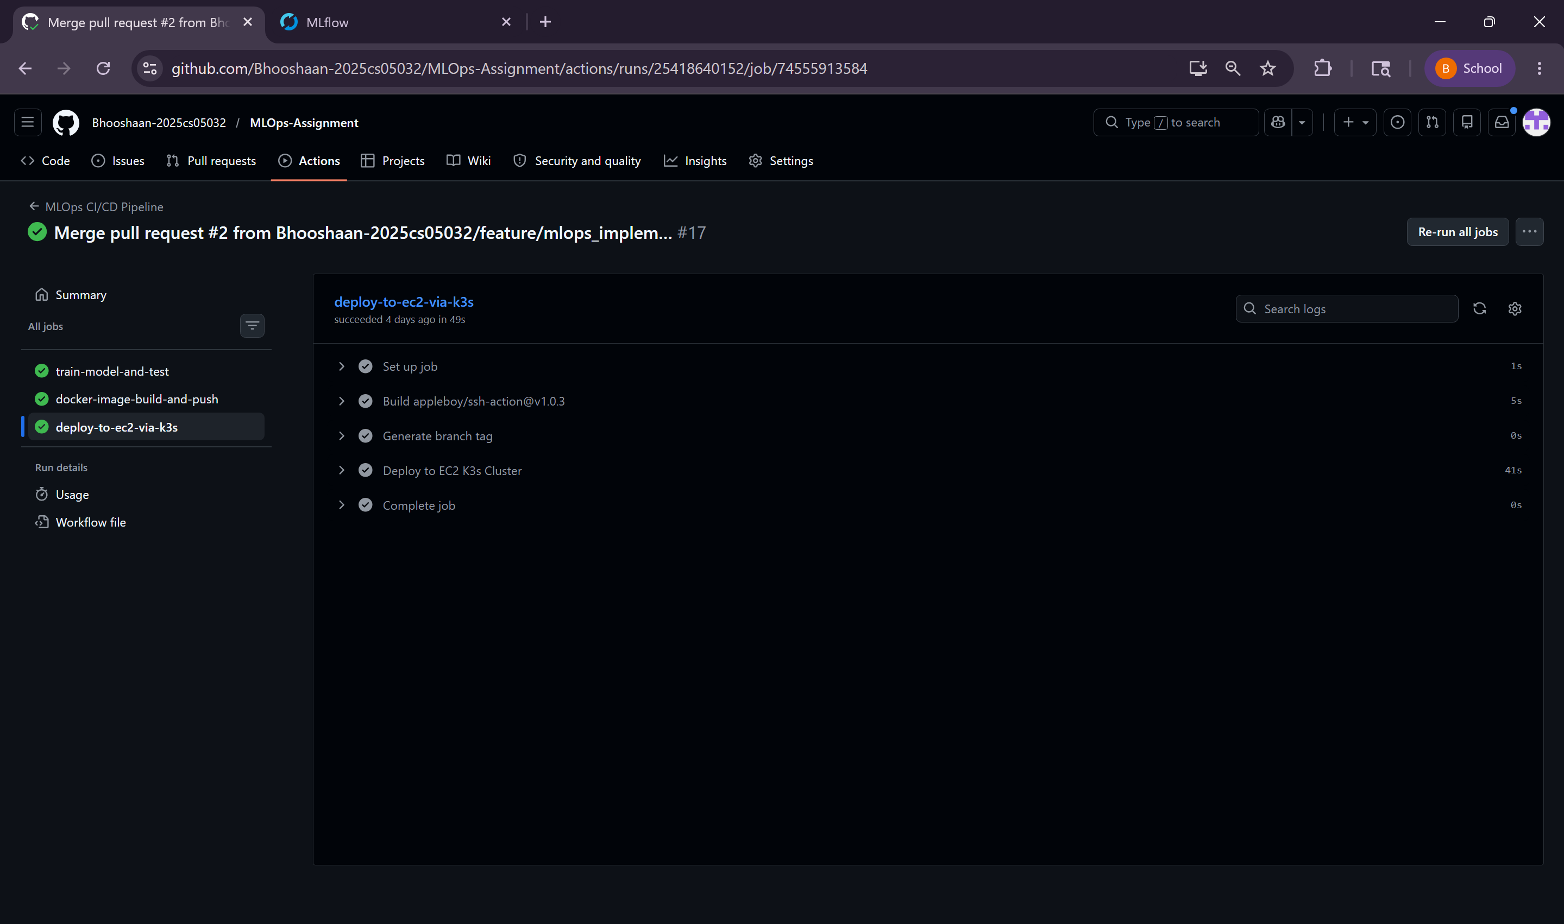

- AWS EC2 Instance t3.small Up and Running
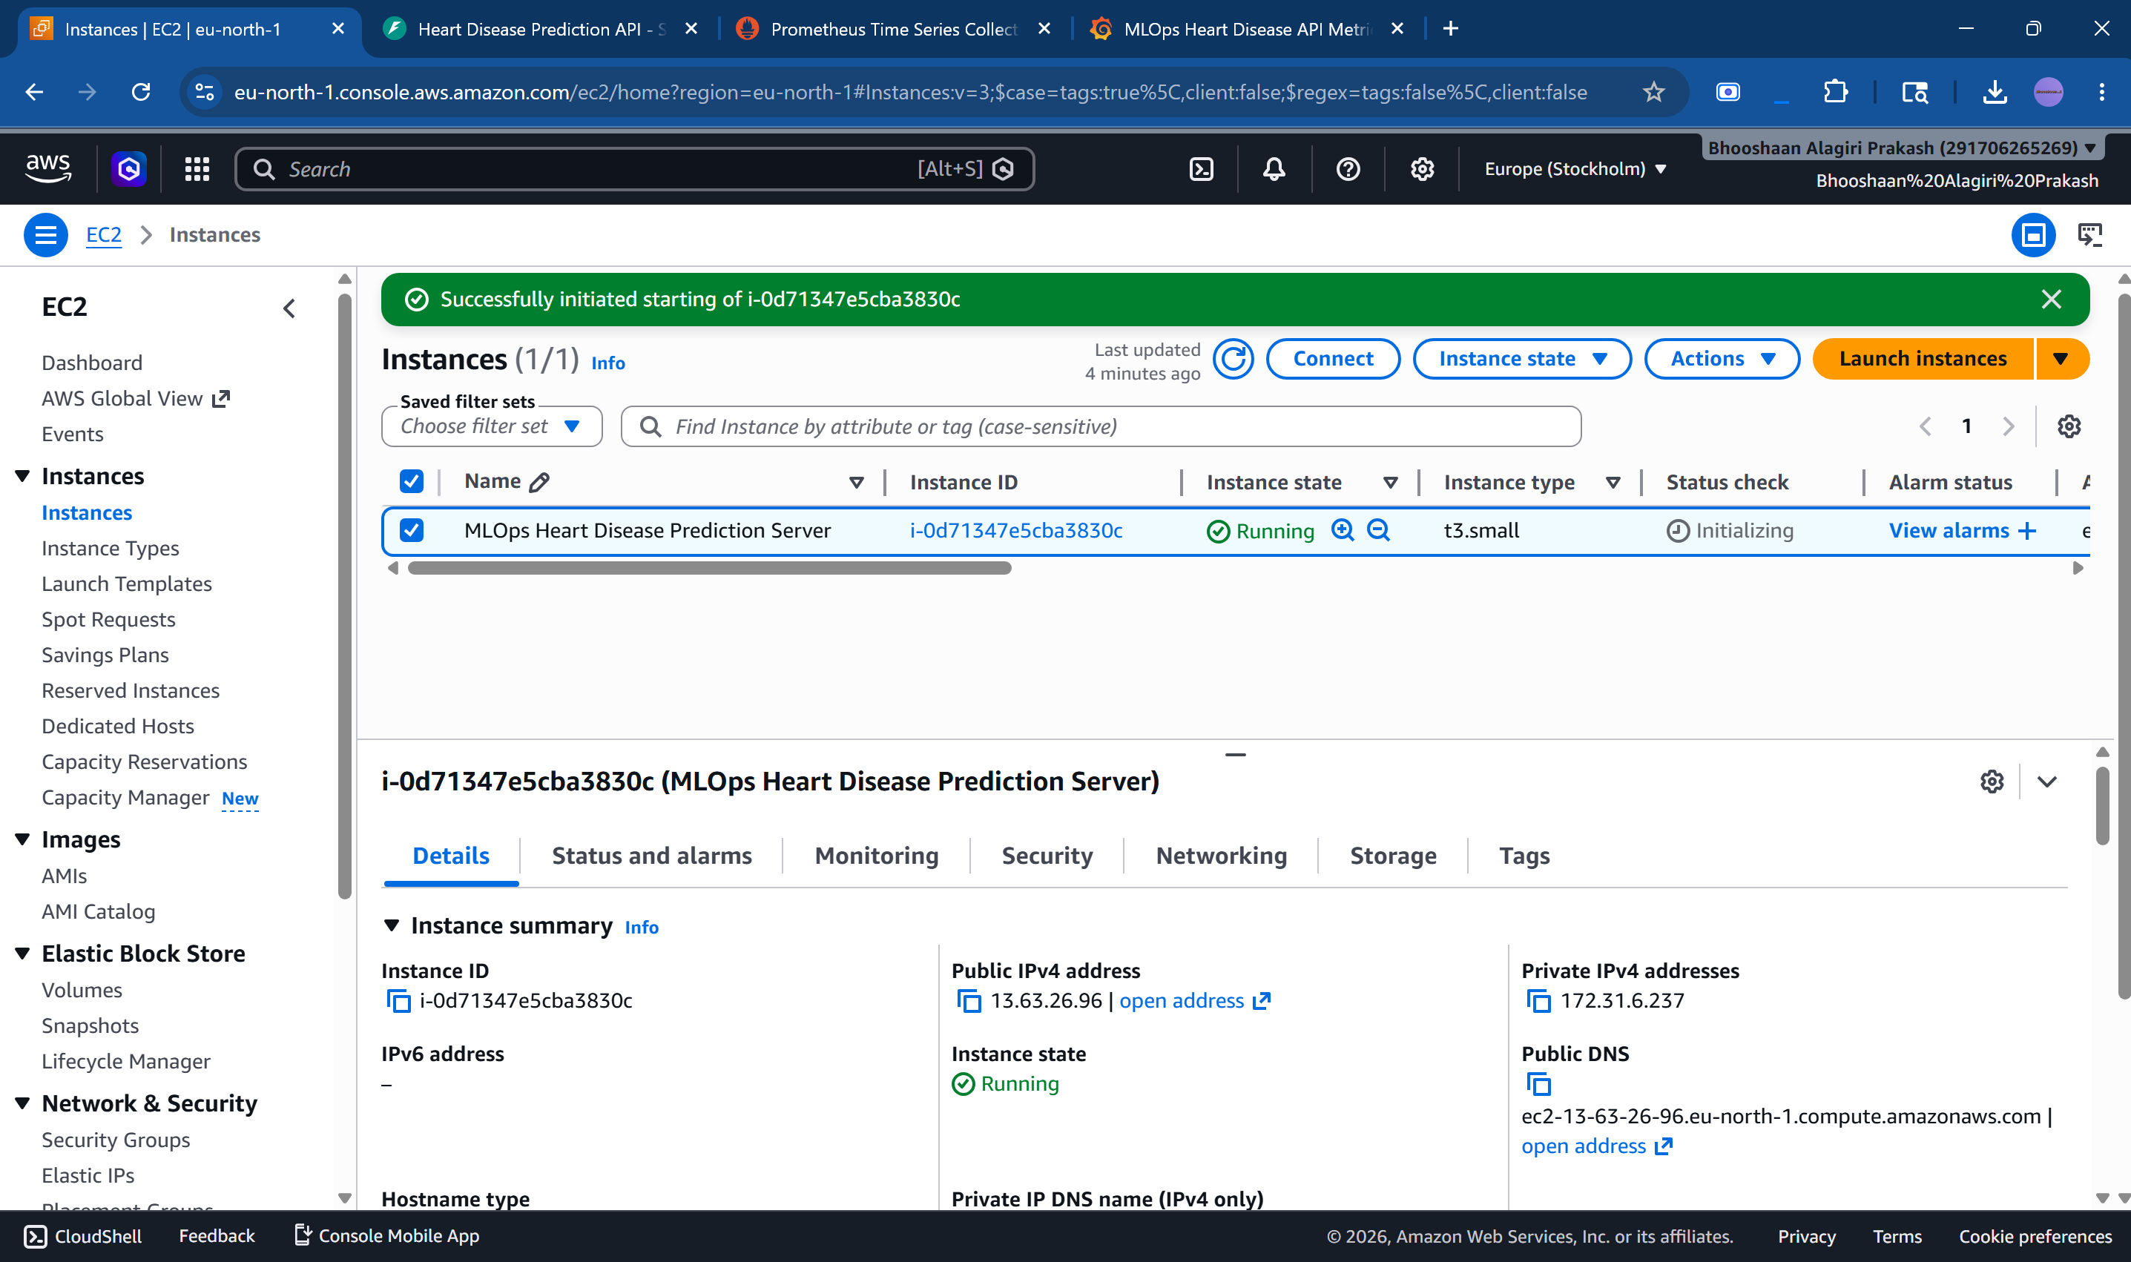

- SSH into Instance and shows active deployment, active pod, kube rollout status successful and Prometheus and Grafana running.
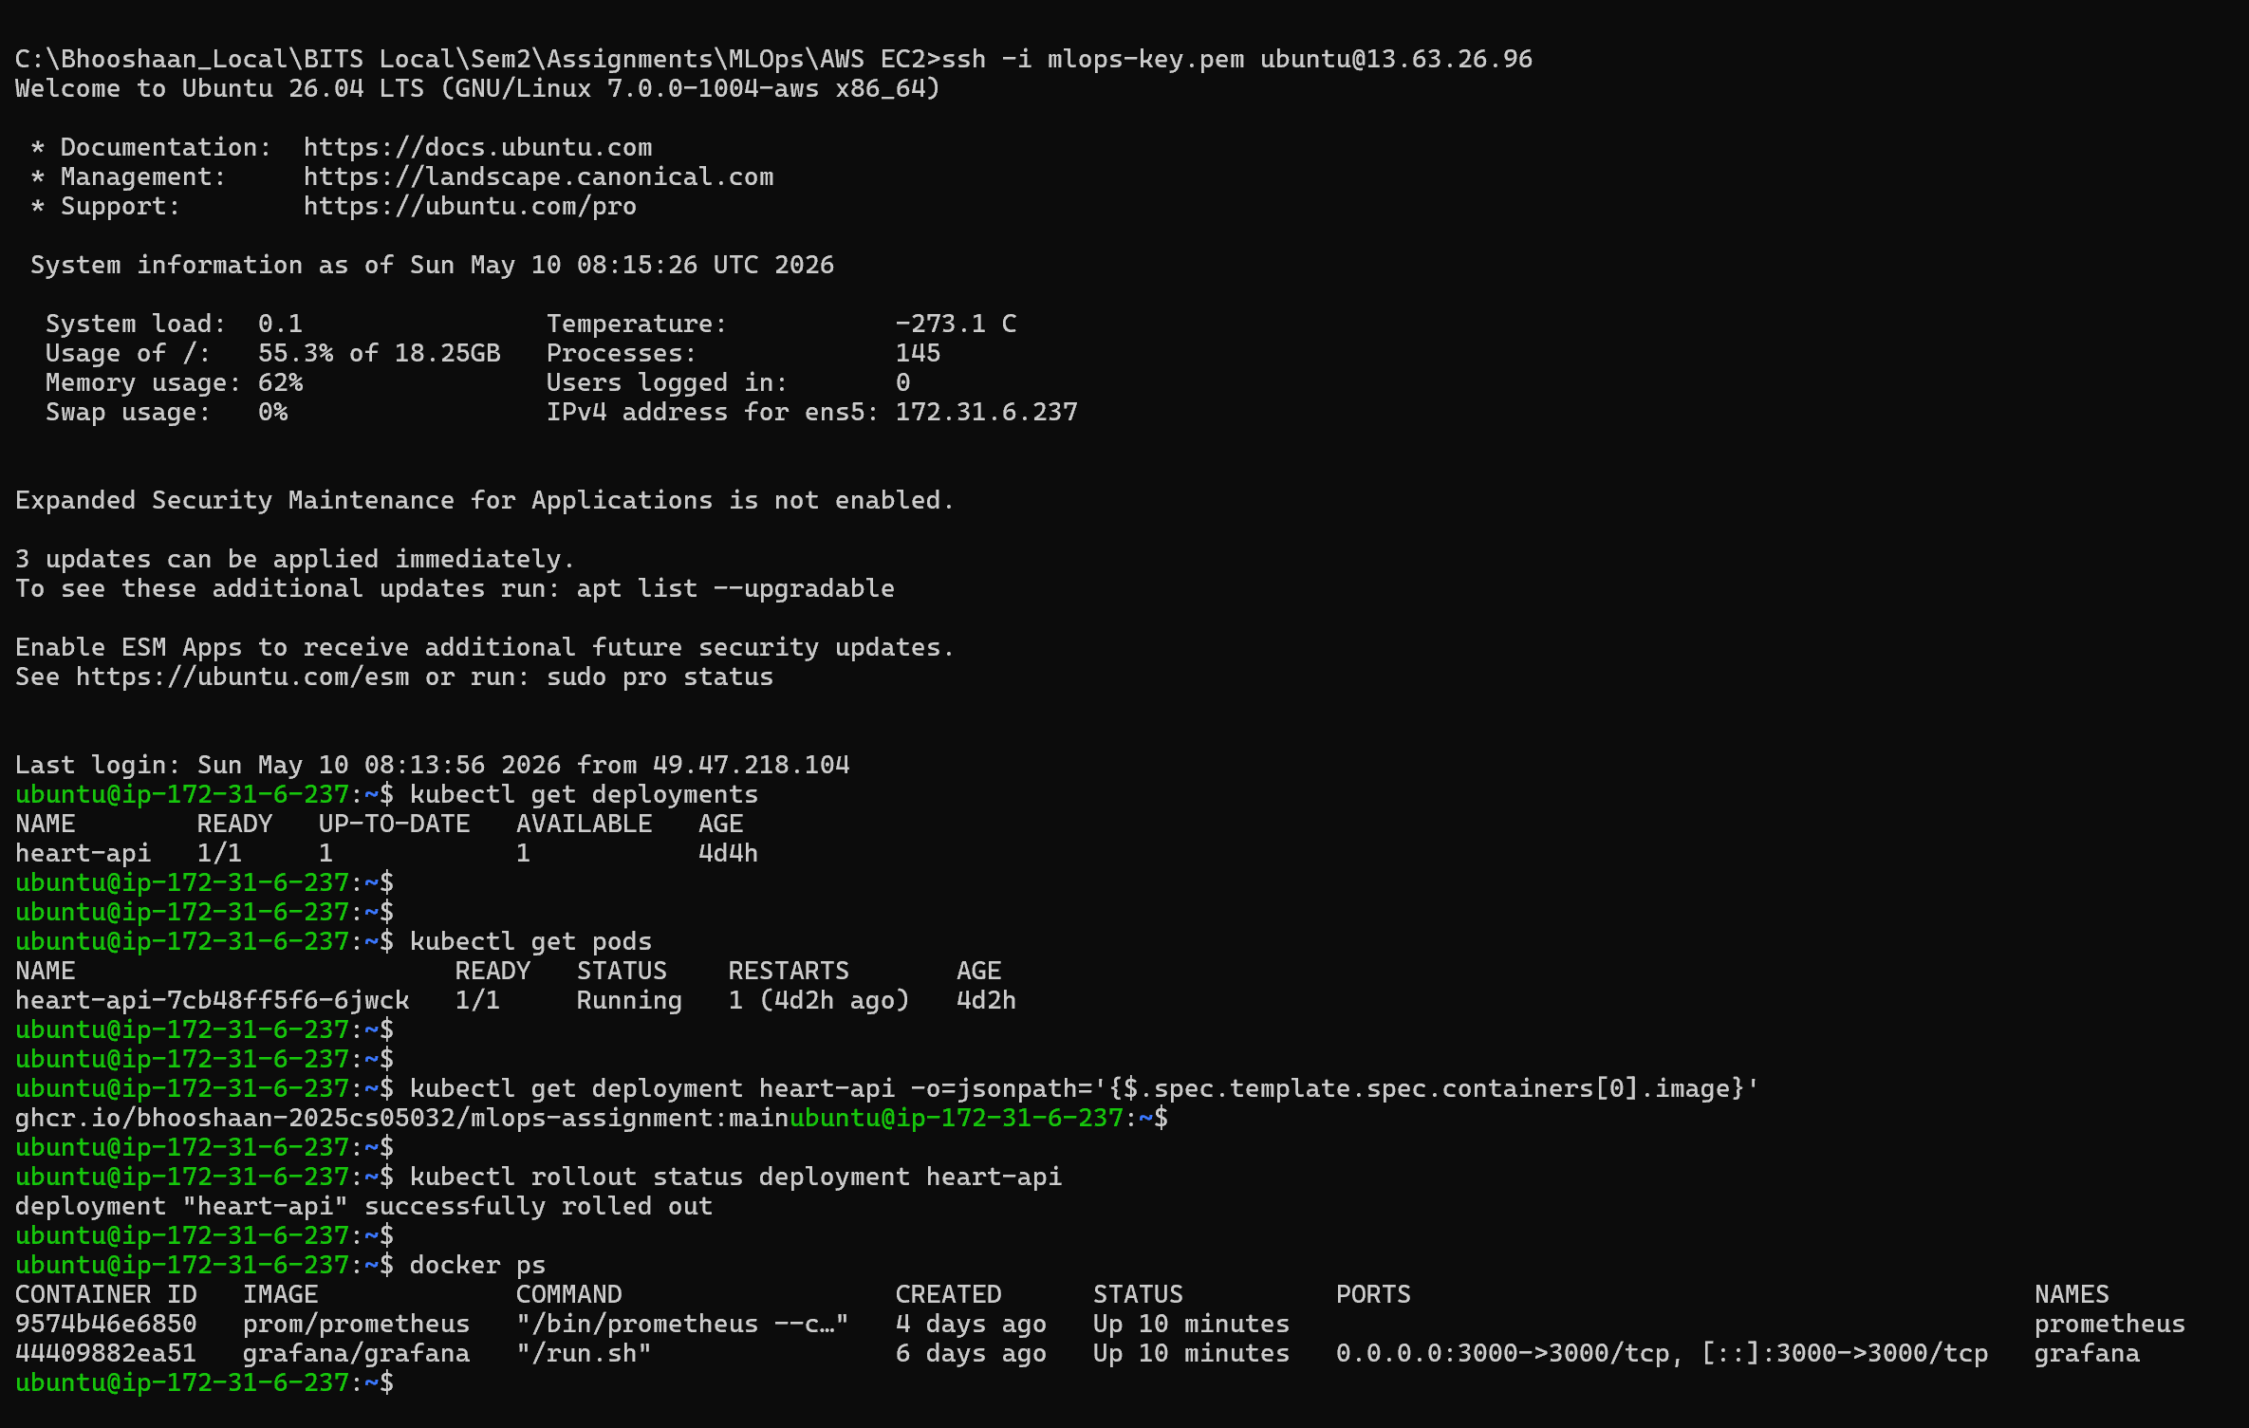

- Sample Prediction Made using the FastAPI Swagger UI
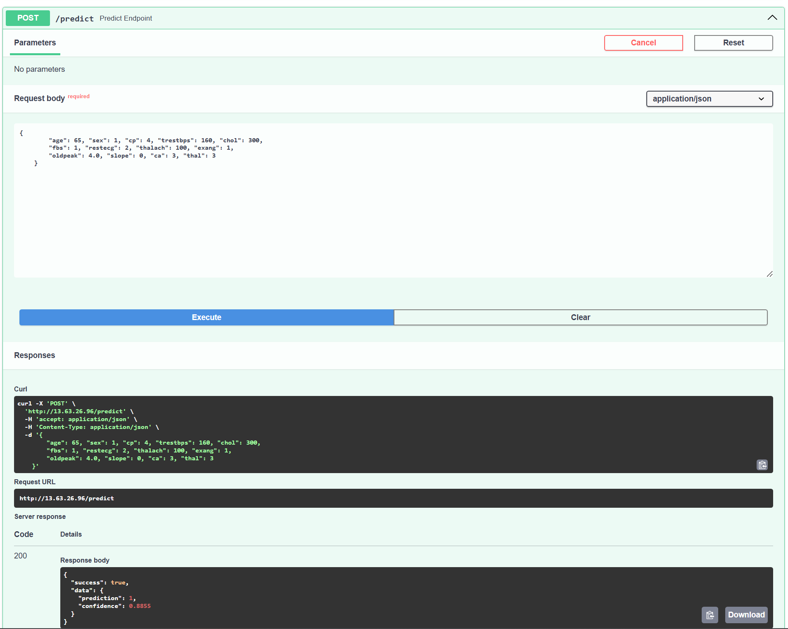
- Prometheus up and scraping the metrics endpoint
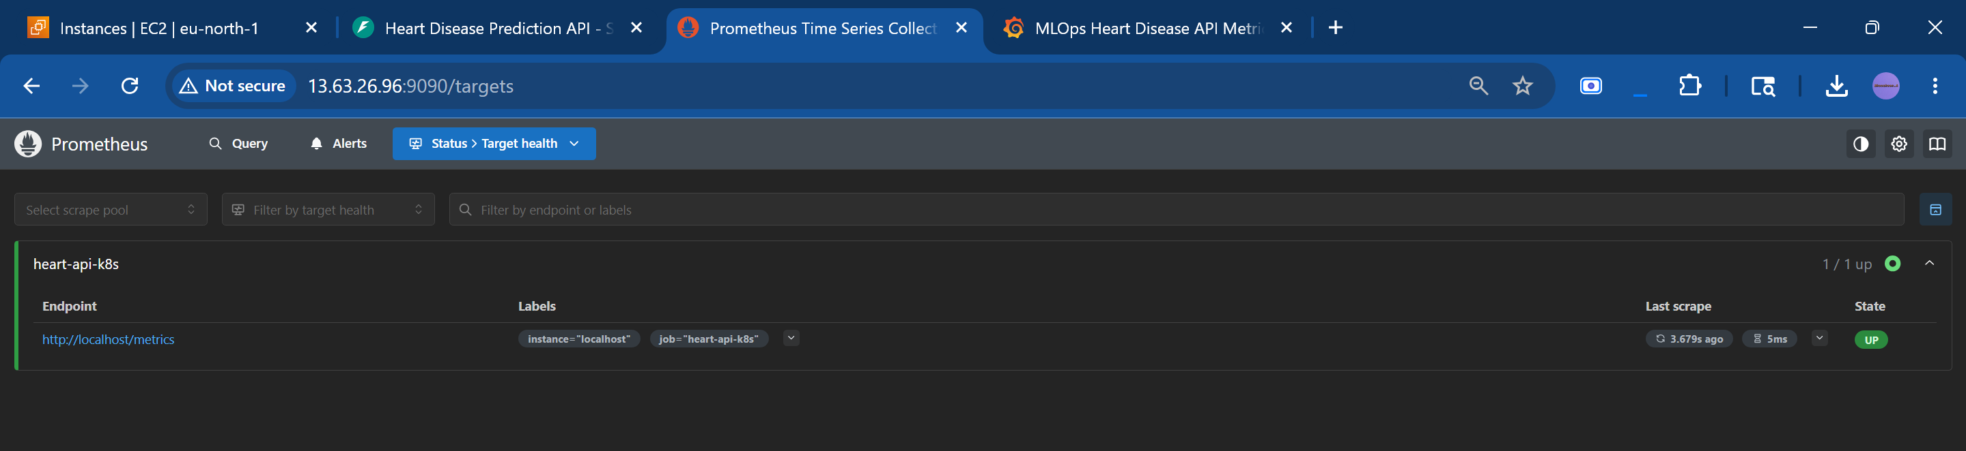
- Grafana Dashboard Up and Running used for monitoring metrics
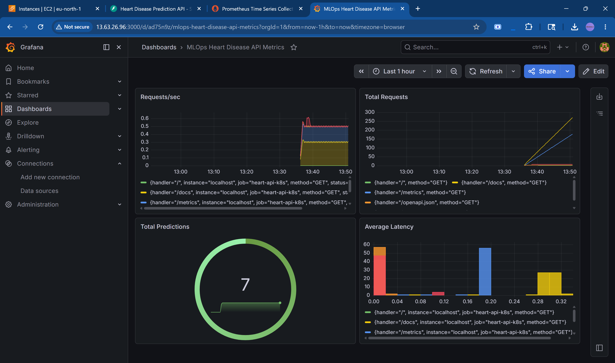
The system supports automatic recovery after EC2 restart because:
- K3s runs as a system service
- Kubernetes restores deployments automatically
- API end-point exposed via Trafeik Ingress
- Prometheus uses Docker restart policy
- Grafana uses Docker restart policy
- Elastic IP maintains stable endpoint access (Elastic IP is created in EC2 mapping to the t3.small instance)

8. Key Features
- End-to-End MLOps workflow
- Automated CI/CD pipeline
- Kubernetes-based deployment
- Ingress-based exposure
- Branch-aware deployments
- Monitoring and observability
- ML experiment tracking
- Containerized inference service
- Rolling deployments
- Secure secret management (Stored in GitHub Secrets)

9. Conclusion
This project demonstrates a production-style MLOps architecture covering:
- Model development
- CI/CD automation
- Containerization
- Kubernetes orchestration
- Monitoring and observability
- Secure deployment practices
- Cloud-native deployment
The implementation provides a strong foundation for scalable and maintainable machine learning systems.

